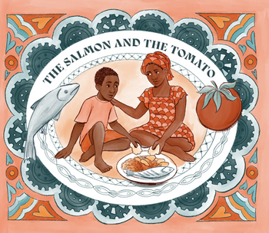

Dear Teacher
The Salmon and the Tomato is a picture book written by a scientist and a teacher and endorsed by Greenpeace Africa. It touches on some really important issues for children to explore in a sensitive way, so I have purchased a copy as a gift for the school/and I think it would be a great idea to ask the authors to become a partner school.
The Salmon and the Tomato is an accessible, empathetic story that encourages children to recognise global connections and consider how collective choices can create a more just and sustainable world. It helps young readers understand how the food on their plates connects them to people and places across the world. Told through the voice of a grandmother explaining the sources of food in an ordinary dinner in the United Kingdom, the story traces the hidden links between farmed salmon and a Spanish tomato and fishermen in Senegal, revealing how simple choices are tied to global systems far afield.
Teaching resources – eight lesson ideas covering art, literacy and PSHE topics – are included in the book, along with explanatory notes for the teacher. The authors have also offered to support teachers to integrate the book into their schools. The book would tie in nicely with Earth Day (April 21st 2026), Refugee week (June 15th-21st 2026) as well, of course, with linking to many Geography, PSHE, Citizenship and Art lessons throughout the year.
More information on the wider project, which will include a graphic novel and a recipe book, can be found on the website www.salmonandtomato.org.
Photos of work produced by schools can be uploaded to the website to form a gallery of inspiration for others. The book will also be used in schools in The Gambia and Senegal, and this gallery will become a global community of hope and ideas.
If any of your teachers would like to discuss the book, the teaching activities, or indeed the wider project, in more detail, please do contact the author team via Juliet Nolan (juliet@salmonandtomato.org).
Yours sincerely,

[Your name]

